Task 2 :- Diminos Store – Delivery Time Analysis
Dataset :- diminos_data.csv
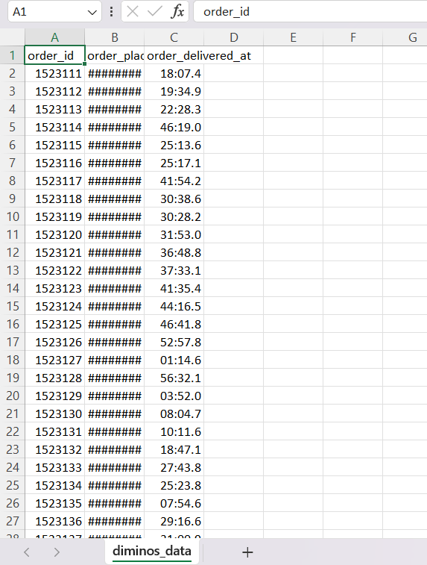

Source code :-
import pandas as pd
import matplotlib.pyplot as plt
# 1. Load Dataset
df = pd.read_csv("diminos_data.csv")
print(df)
Output :-
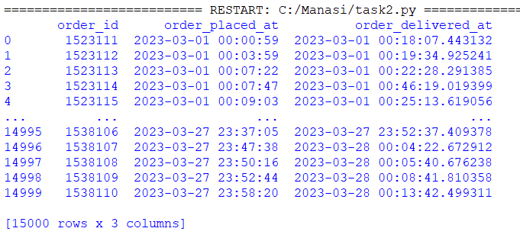

Source code :-
# 2. Convert to datetime
df['order_placed_at'] = pd.to_datetime(df['order_placed_at'])
df['order_delivered_at'] = pd.to_datetime(df['order_delivered_at'])
# 3. Calculate delivery time (minutes)
df['delivery_time_min'] = (
df['order_delivered_at'] - df['order_placed_at']
).dt.total_seconds() / 60
# 4. Basic statistics
stats = df['delivery_time_min'].describe(
percentiles=[0.5, 0.9, 0.95, 0.99]
)
print("\nDelivery Time Statistics:\n", stats)

Output :-
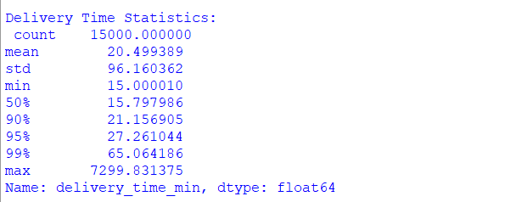

Source code :-
# 5. 95th Percentile Check
p95 = df['delivery_time_min'].quantile(0.95)
print("\n95th Percentile Delivery Time:", round(p95, 2), "minutes")
if p95 < 31:
print(" SLA MET: 95th percentile is within 31 minutes")
else:
print(" SLA VIOLATED: 95th percentile exceeds 31 minutes")
Output :-
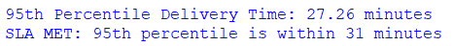

Source code :-
# 6. Percentage of orders within 31 minutes
within_31 = (df['delivery_time_min'] <= 31).mean() * 100
print("\nOrders delivered within 31 minutes:", round(within_31, 2), "%")
Output :-
Source code :-
# 7. Identify delayed orders
late_orders = df[df['delivery_time_min'] > 31]
print("\nTotal Late Orders:", len(late_orders))
Output :-
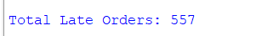

Source code :-
# 8. Remove extreme outliers (>120 min)
clean_df = df[df['delivery_time_min'] <= 120]
clean_p95 = clean_df['delivery_time_min'].quantile(0.95)
print("\n95th Percentile after removing outliers:", round(clean_p95, 2))
Output :-

Source code :-
# 9. Visualization – Delivery Time Distribution
plt.figure()
plt.hist(clean_df['delivery_time_min'], bins=50)
plt.axvline(31)
plt.xlabel("Delivery Time (minutes)")
plt.ylabel("Number of Orders")
plt.title("Delivery Time Distribution (Cleaned Data)")
plt.show()

Output :-
